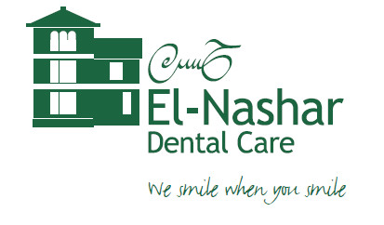
Health and Safety Policy
Statement of General Policy

This is the Health and Safety Policy Statement of El-Nashar Dental Care.
].

Statement of Intent

To ensure, so far as is reasonably practicable, a safe and healthy working environment for all our employees and self-employed members of the dental team as well as for patients and members of the public who work within or visit our premises.

We will implement, maintain and review appropriate safe systems of work to control and reduce, so far as is reasonably practicable, the health and safety risks arising from all activities at the practice and take all reasonable steps and measures to minimise our activity’s impact upon the environment.

We will consult with the dental team on all matters affecting their health and safety. Any concerns raised will be investigated and appropriate actions taken.

Training, information, supervision, and instruction will be provided to all team members for the understanding of health and safety issues and to ensure that they are competent to carry out their tasks.

We will provide and maintain safe equipment and ensure the safe use and handling of hazardous and non-hazardous substances. Suitable and sufficient precautions will be taken to prevent accidents and cases of work-related illness.

All staff will be made aware of this health and safety policy document, a copy of which is displayed prominently within the practice.

Breaches of health and safety rules may lead to action under the practice disciplinary procedure.

This Health and Safety Policy will be reviewed annually and in any event of a significant change of working practises.

Practice owner’s signature

